A Project Report On:

QUIZ APP

Submitted in partial fulfilment of the requirements for the award of the degree

Bachelor of Science (Information Technology) (BSc-IT)

Academic Year 2026 – 2027

Group Members:
James Snortti Satiah | 92400588065
Patrick Nyan Suah | 92400588079
Paias Poiye | 92400588005

Internal Guide



Rajkot-Morbi Road, At & PO: Gauridad, Rajkot 360 003. Gujarat. India.

Bachelor of Science (Information Technology)
(B.Sc. IT)



This is to certify that the project work entitled

QUIZ APP

Submitted in partial fulfillment of the requirement for

The award of the degree of
Bachelor of Science (Information Technology)

Of the

Marwadi University

Is a result of the bonafide work carried out by
James Snortti Satiah | 92400588065
Patrick Nyan Suah | 92400588079
Paias Poiye | 92400588005

During the Academic Year 2026-27

Sem-5

Computer Applications Dr. Sunil Bajeja Dr R. Sridaran
Faculty HOD Dean

DECLARATION

We hereby declare that this project work, entitled QUIZ APP,' is a record compiled by the team.

We also declare that the matter embodied in this project is a genuine work done by the team and has not been submitted to this University or to any other University/Institution for the fulfilment of the requirements of any course of study.

Place: Faculty of Computer Applications, Marwadi University, Rajkot, Gujarat.

Date:

Patrick Nyan Suah 92400588079 Signed: _____________
James Snortti Satiah 92400588079 Signed: _____________
Paias Poiye 92400588005 Signed: _____________

ACKNOWLEDGEMENT

It is indeed a great pleasure to express our thanks and gratitude to all those who helped us. No serious and lasting achievement or success can ever be achieved without the help of friendly guidance and the cooperation of so many people involved in the work.

We are very thankful to our guide TIRTH BHADESHIYA Sir, the person who made us follow the right steps during our project work. We express our deep sense of gratitude for her guidance, suggestions and expertise at every stage. Apart from her valuable and expert suggestions, the documentation of our report indeed helped us a lot.

Thanks to our friends and colleagues who have been a source of inspiration and motivation that helped us during our project work.

We are heartily thankful to the Dean of our department, Dr R. Sridaran sir, and the HOD, Dr. Sunil Bajeja sir, for allowing us to work on this project and for their endless and great support to all those who, directly or indirectly, supported and helped us fulfil our task.

Patrick Nyan Suah 92400588079 Signed: _____________
James Snortti Satiah 92400588079 Signed: _____________
Paias Poiye 92400588005 Signed: _____________

Table of Contents:

Chapters | Particulars | Page No.
1 | INTRODUCTION TO PROJECT DEFINITION | 5
2  2.1 | Preamble  Module description | 6
3 | Study of the existing system | 7
4  4.1  4.2 | TECHNICAL DESCRIPTION  Hardware Requirement  Software Requirement | 7
5  5.1  5.2  5.3  5.4  5.5  5.6 | SYSTEM DESIGN AND DEVELOPMENT  - Algorithm  - Flow Chart  - Data Flow Diagram  - Class Diagram  - Use Case Diagram  - Sequential Diagram  - Activity Diagram  - State Diagram  DATABASE DESIGN / FILE STRUCTURE  Menu Design  Screen Design  Code of the module | 7
6 | Conclusion | 12
7  7.1 | LEARNING DURING PROJECT WORK  Future Enhancement | 12
8  8.1  8.2 | BIBLIOGRAPHY  Online References  Offline References | 13

Chapter 1: Introduction to Project Definition:

1.1 Project Overview:

Background
In today's digital age, online learning platforms have become increasingly important for education and skill development. Quizzes serve as effective tools for knowledge assessment, self-evaluation, and reinforcement learning. However, many existing solutions are either too complex, expensive, or lack essential features for both learners and content creators.

The Solution
QuizApp addresses these challenges by providing a lightweight, accessible, and feature-rich quiz platform. Built with Django, it offers:
For Users:
- Easy registration and login
- Access to multiple quizzes across various categories
- Real-time feedback on answers
- Performance tracking and statistics
- Review of incorrect answers
For Administrators:
- Intuitive content management through admin panel
- Ability to create quizzes with custom questions
- Support for different difficulty levels (Easy, Medium, Hard, Expert)
- Category-based organization of questions
- User performance monitoring

Key Features
Feature | Description
User Authentication | Secure registration, login, and logout functionality
Quiz Library | Multiple quizzes with categorized questions
Interactive Interface | Progress tracking, instant feedback, score display
Results Analytics | Percentage scores, grade calculation, category breakdown
Mistake Review | Users can review and learn from incorrect answers
Admin Panel | Full CRUD operations for quizzes and questions
Responsive Design | Works on desktop, tablet, and mobile devices
Security | CSRF protection, session management, password validation

Technology Stack
Component | Technology
Backend Framework | Django 6.0.5
Frontend | HTML5, CSS3, JavaScript
Database | SQLite3 (development)
Server | Django Development Server
Authentication | Django Auth System
Version Control | Git

1.2 Problem Statement:
Traditional methods of conducting quizzes and assessments face several challenges:
- Time-Consuming Manual Processes
- Creating, distributing, and grading paper-based quizzes is inefficient
- Immediate feedback is not possible
- Tracking student progress over time is difficult
- Limited Accessibility
- Physical presence required for quiz taking
- Geographic and time constraints
- Difficulty in reaching remote learners
- Lack of Analytics and Insights
- No automated performance tracking
- Difficulty identifying knowledge gaps
- No visualization of learning progress
- Content Management Challenges
- Updating quiz content is cumbersome
- No centralized repository for questions
- Difficulty categorizing and organizing questions by difficulty
- Scalability Issues
- Manual systems cannot handle large numbers of users
- No automated grading for multiple users
- Resource-intensive for educators

1.3 Project Objectives:
- To Develop an Interactive Quiz Application
- Create a web-based platform where users can take quizzes
- Provide an intuitive and engaging user interface
- Support multiple question types and difficulty levels
- To Implement Secure User Authentication
- Allow users to register and create accounts
- Secure login and session management
- Protect sensitive user data and quiz content
- To Provide Comprehensive Quiz Management
- Enable administrators to create, edit, and delete quizzes
- Support adding questions with options and correct answers
- Organize content by categories and difficulty levels
- To Deliver Meaningful Feedback and Analytics
- Provide instant feedback on quiz answers
- Show final scores with percentage and grade
- Allow users to review their mistakes
- Display performance by category
- To Ensure Accessibility and Responsiveness
- Make the application accessible on various devices
- Implement responsive design principles
- Provide a consistent user experience across platforms

1.4 Scope of the Project:

In-Scope Features
Phase 1: Core Functionality
- User registration, login, and logout
- Quiz creation and management
- Question creation with multiple-choice options
- Interactive quiz-taking with progress tracking
- Score calculation with percentage and grade
- Answer feedback (correct/incorrect)
- Result history and statistics
- Mistake review functionality

Phase 2: User Experience
- Responsive web design
- Intuitive navigation
- Visual feedback (animations, progress bars)
- Professional styling with gradients and cards
- Modal dialogs for confirmations
- Success and error messages

Phase 3: Content Management

- Admin panel for quiz management
- Question categorization
- Difficulty level assignment (Easy, Medium, Hard, Expert)
- Point-based scoring system
- Quiz description and metadata

Phase 4: Security
- Session-based authentication
CSRF protection
- Password validation
- Admin-only access to management features
- User-specific data isolation

Chapter 2: Preamble & Module Description:

2.1 System Architecture:

QuizApp follows Django's Model-View-Template (MVT) architectural pattern, which is Django's implementation of the Model-View-Controller (MVC) pattern. This architecture provides a clean separation of concerns, making the application modular, maintainable, and scalable.

Architectural Diagram

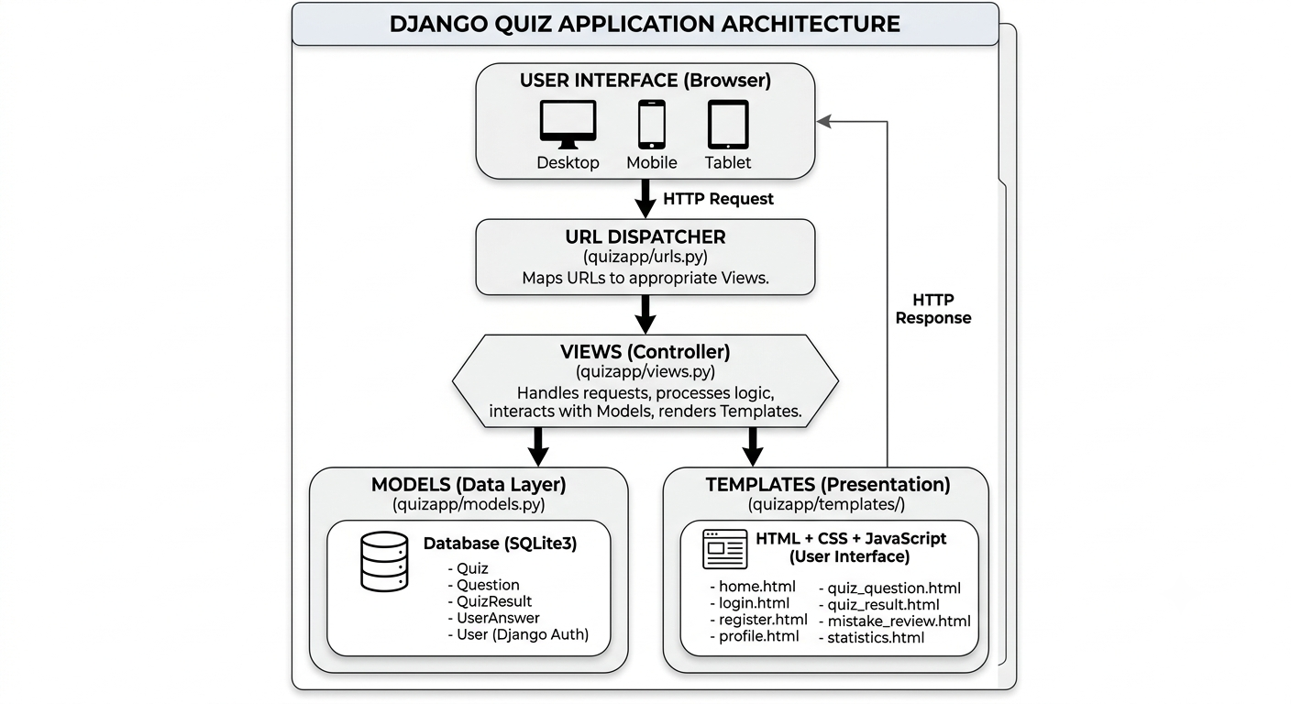

System Components

Presentation Layer (Templates)
The presentation layer consists of HTML templates with embedded Django template tags and CSS/JavaScript for interactivity.
Key Files:
- templates/quizapp/*.html
- static/quizapp/css/style.css
- static/quizapp/js/quiz.js
Responsibilities:
- Render user interface
- Display data from views
- Handle client-side interactions
- Provide responsive design

Business Logic Layer (Views)
The views contain all the application logic, handling user requests, processing data, and returning appropriate responses.
Key Files:
- views.py - Contains all view functions
Responsibilities:
- Process HTTP requests (GET/POST)
- Validate user input
- Interact with models (CRUD operations)
- Manage session data
- Render templates with context data
- Handle authentication and authorization
- Return JSON responses for AJAX calls

Data Layer (Models)
The models define the data structure and provide an abstraction layer for database operations.
Key Files:
- models.py - Defines all database models
- admin.py - Admin interface configuration
Models:
- Quiz - Stores quiz information
- Question - Stores individual questions
- QuizResult - Stores quiz attempt results
- UserAnswer - Stores individual answer records
- User (Django built-in) - User authentication
Responsibilities:
- Define database schema
- Provide ORM (Object-Relational Mapping)
- Handle data validation
- Manage relationships between models
- Support CRUD operations

URL Configuration (Routing)
The URL dispatcher maps incoming URLs to the appropriate view functions.
Key Files:
- quizproject/urls.py - Main URL configuration
- quizapp/urls.py - App-specific URL patterns
Responsibilities:
- Route URLs to views
- Extract URL parameters
- Support named URL patterns
- Enable reverse URL resolution

System Flow

User Request Flow:
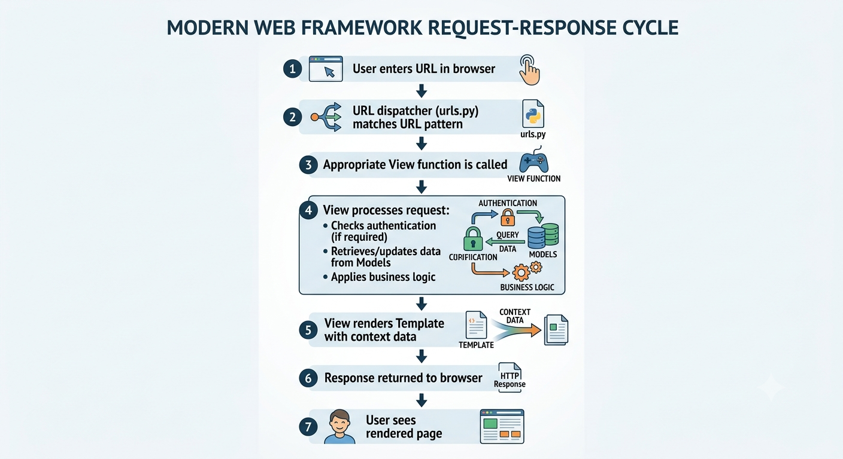

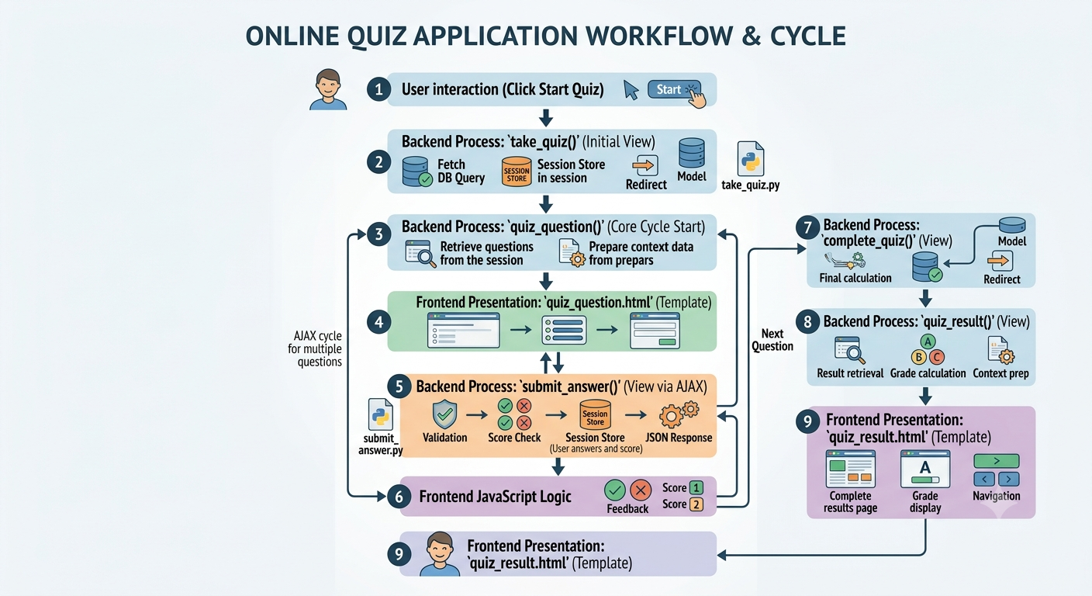
Quiz Taking Flow:

  - Module Description:

- User Authentication Module
This module manages all user-related operations including registration, login, logout, and profile management. It utilizes Django's built-in authentication framework to provide secure user account management. The module handles user registration with password validation, session-based login/logout functionality, and profile display with personal statistics. It ensures that only authenticated users can access quiz-taking features while guests can only view the homepage and statistics.

- Quiz Management Module
This module provides administrative functionality for creating and managing quizzes and questions. Through Django's admin interface, administrators can create quizzes, add questions with multiple-choice options, assign difficulty levels (Easy, Medium, Hard, Expert), categorize questions, and set point values. The module also handles the underlying data models that define the structure of quizzes and questions stored in the database.

- Quiz Taking Module
The quiz taking module delivers an interactive quiz-taking experience. It manages the entire quiz flow from initialization to completion, including loading questions from the database, storing quiz data in user sessions, displaying questions with options, and processing answers via AJAX for seamless user experience. The module provides real-time feedback on answers, tracks progress with a visual progress bar, and maintains the current score throughout the quiz session.

- Results and Analytics Module
This module handles the calculation, storage, and display of quiz results and performance analytics. It calculates final scores, percentages, and letter grades (A+, A, B, C, F), provides category-wise performance breakdowns, and enables users to review their mistakes with correct answers displayed alongside their incorrect responses. The module also aggregates platform-wide statistics including total quizzes, total questions, total attempts, and average scores.

- User Profile Module
The user profile module displays personalized information and quiz history for authenticated users. It shows user details, total quizzes taken, average score, and a detailed history of all quiz attempts with performance badges (Excellent, Good, Needs Practice). The module also includes a clear history feature that allows users to delete their quiz records with a confirmation dialog.

- Template and UI Module
This module provides the user interface components, styling, and client-side interactivity for the application. It consists of HTML templates for all pages, CSS styling for a professional gradient-based design, and JavaScript for dynamic functionality including AJAX requests, modal dialogs, and interactive UI updates. The module implements responsive design principles, ensuring the application is accessible on desktop, tablet, and mobile devices.

- Data Persistence Module
The data persistence module manages all database operations using Django's Object-Relational Mapping (ORM) and SQLite3 database. It defines the four main data models: Quiz (stores quiz information), Question (stores individual questions with options), QuizResult (stores quiz attempt results), and UserAnswer (stores individual answer records). The module handles CRUD operations and database migrations for schema updates.

- Security Module
This module ensures application security through multiple layers of protection including authentication, authorization, CSRF protection, and password validation. It implements Django's built-in security features such as session-based authentication, login-required decorators for protected views, CSRF tokens for form submissions, and password validation rules. The module provides role-based access control distinguishing between guests, authenticated users, and administrators.

- Session Management Module
The session management module handles user session data during quiz-taking activities. It stores critical quiz state information including the current quiz ID, question data, current question index, score, and user answers. This module enables seamless navigation through quiz questions while maintaining state across multiple HTTP requests and ensures proper cleanup after quiz completion.

2.2.1 User Authentication Module

Purpose: Manage user accounts and authentication.
Components:
- views.py - custom_login(), custom_logout(), register(), profile()
- templates/quizapp/login.html
- templates/quizapp/register.html
- templates/quizapp/profile.html
Functions:
Function | Method | Description
register() | GET/POST | Handles user registration
custom_login() | GET/POST | Handles user login
custom_logout() | GET | Handles user logout
profile() | GET | Displays user profile
Features:
- User registration with password validation
- Secure login with password hashing
- Session-based authentication management
- Logout with confirmation modal
- User profile with quiz history and statistics
- Restricted access to authenticated pages using @login_required decorator
- Success and error messages for user feedback
Dependencies:
- Django Authentication Framework
- User model (Django built-in)
- QuizResult model

2.2.2 Quiz Management Module (Admin)
Purpose: Enable administrators to manage quizzes, questions, categories, and difficulty levels through the admin interface.
Components:
- models.py - Quiz and Question data models
- admin.py - Admin interface configuration
- templates/quizapp/manage_quizzes.html
Functions:
Function | Method | Description
Admin Panel | GET/POST | Create, edit, delete quizzes
Admin Panel | GET/POST | Add, edit, delete questions
Quiz.total_questions() | Method | Returns total questions in quiz
Question.get_options() | Method | Returns options as a list
Features:
- Create, edit, and delete quizzes with name and description
- Add, edit, and delete questions with text and options
- Categorize questions by subject/topic
- Assign difficulty levels (Easy, Medium, Hard, Expert)
- Set custom point values for each question
- View all quiz content in organized list
- Admin-only access with authentication
Dependencies:
- Django Admin Framework
- Quiz model
- Question model
- Django Authentication (admin access only)

2.2.3 Quiz Taking Module
Purpose: Provide an interactive quiz-taking experience with real-time feedback and progress tracking.
Components:
- views.py - take_quiz(), quiz_question(), submit_answer()
- templates/quizapp/quiz_question.html
- static/quizapp/js/quiz.js
Functions:
Function | Method | Description
take_quiz() | GET | Initialize quiz session with questions
quiz_question() | GET | Display current question with options
submit_answer() | POST | Process and validate user's answer
Features:
- Session-based question tracking
- Visual progress bar showing completion percentage
- Real-time score tracking
- Instant feedback on answer submission
- Category and difficulty level display
- AJAX-based answer submission
- Automatic navigation between questions
Dependencies:
- Django Session Framework
- Quiz model
- Question model

2.2.4 Results and Analytics Module
Purpose: Display and analyze quiz results.
Components:
- views.py - complete_quiz(), quiz_result(), mistake_review(), statistics()
- templates/quizapp/quiz_result.html
- templates/quizapp/mistake_review.html
- templates/quizapp/statistics.html
Functions:
Function | Method | Description
complete_quiz() | GET | Complete quiz, save results
quiz_result() | GET | Display quiz results
mistake_review() | GET | Display incorrect answers
statistics() | GET | Display overall statistics
Features:
- Final score calculation
- Percentage and grade display
- Category-wise performance breakdown
- Mistake review with correct answers
- Overall platform statistics
- Quiz attempt history
Dependencies:
- QuizResult model
- UserAnswer model
- Django Aggregation (Avg)

2.2.5 User Profile Module

Purpose: Display user-specific information and history.
Components:
- views.py - profile(), clear_history()
- templates/quizapp/profile.html
Functions:
Function | Method | Description
profile() | GET | Display user profile
clear_history() | POST | Clear quiz history
Features:
- User information display
- Quiz history with performance badges
- Average score calculation
- Total quizzes taken
- Clear history with confirmation
- Detailed result view
Dependencies:
- QuizResult model
- Django Authentication

2.2.6 Template and UI Module
Purpose: Provide user interface and styling.
Components:
- templates/quizapp/*.html - All HTML templates
- static/quizapp/css/style.css - CSS styling
- static/quizapp/js/quiz.js - JavaScript functionality
Templates:
Template | Purpose
home.html | Main landing page
login.html | User login form
register.html | User registration form
profile.html | User profile and history
quiz_question.html | Quiz-taking interface
quiz_result.html | Quiz results display
mistake_review.html | Incorrect answers review
statistics.html | Platform statistics
CSS Features:
- Responsive design
- Gradient backgrounds
- Card-based layout
- Hover effects and animations
- Professional color scheme
JavaScript Features:
AJAX answer submission
- Modal dialogs
- Progress tracking
- Dynamic UI updates
- Confirmation dialogs

2.2.7 Data Persistence Module
Purpose: Manage database operations.
Components:
- models.py - Data models
- db.sqlite3 - Database file
- migrations/ - Database migrations
Models:
Model | Purpose
Quiz | Quiz information and metadata
Question | Individual questions with options
QuizResult | Quiz attempt results
UserAnswer | Individual answer records
User (Django) | User authentication and profile

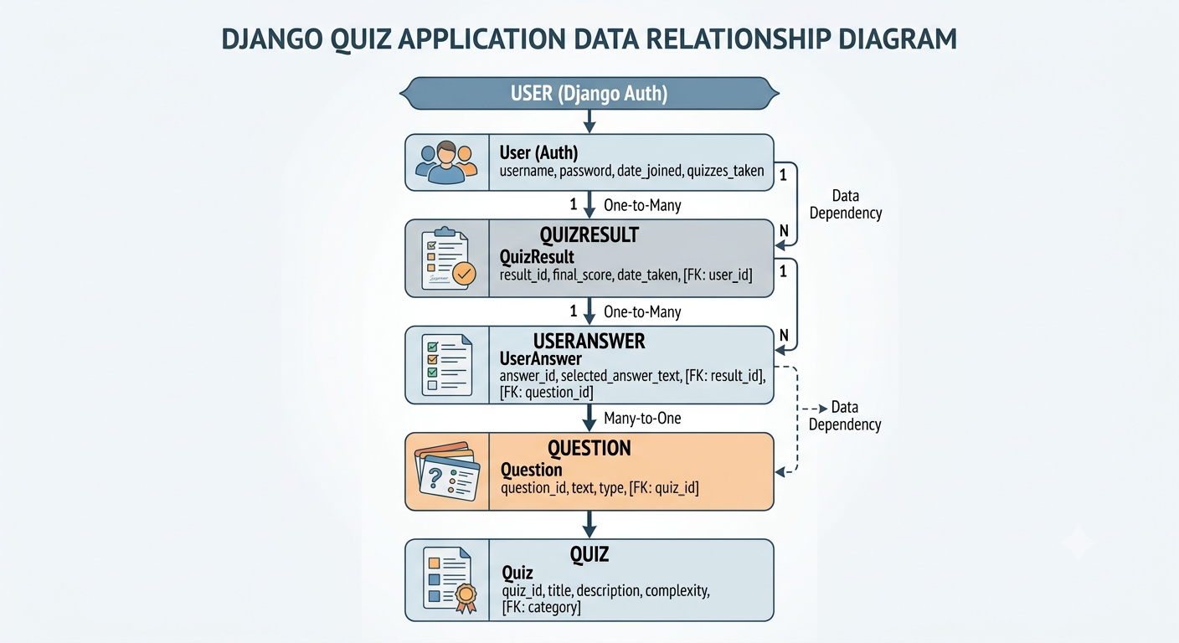
Data Relationships:

Migrations:
- Automatic schema updates
- Version control for database
- Rollback support
Dependencies:
- Django ORM
- SQLite3

Chapter 3: Study of Existing System

A study of existing quiz and assessment systems reveals a diverse landscape ranging from traditional paper-based methods to sophisticated web-based platforms. Popular solutions such as Kahoot!, Quizizz, and Quizlet offer engaging, gamified experiences but are primarily focused on entertainment and memorization, with limited customization and data control. More comprehensive platforms like Moodle and Google Forms provide robust assessment features but often come with complexity, cost, or lack of difficulty-based categorization and detailed performance analytics. Desktop applications like Adobe Captivate offer professional eLearning capabilities but require significant technical expertise and financial investment. Common gaps identified across these systems include limited support for difficulty-based question categorization, lack of self-hosted open-source options, basic mistake review functionality, and minimal category-wise performance analysis. QuizApp addresses these gaps by providing a customizable, self-hosted, open-source solution with difficulty levels, comprehensive analytics, and detailed mistake review, all within a modern, responsive interface.

3.1 Overview of Existing Systems
Quiz and examination systems currently available can be divided into two main categories:

3.1.1 Online Quiz Platforms
Examples include Kahoot!, Quizlet, Google Forms, and Moodle Quiz. These platforms offer rich features such as multimedia questions, real-time leaderboards, and detailed analytics. However, they require a stable internet connection, central servers, and often a paid subscription for full functionality.

3.1.2 Offline Quiz Tools
Examples include some desktop-based examination software (e.g., TCExam offline mode, Qedoc Quiz Player) and simple command-line quiz scripts. These work without internet but often lack modern graphical interfaces, user management, multiple categories, and timed questions.

3.2 Limitations of Existing Systems

Online Platforms:
- Require continuous internet access, making them unusable in areas with poorconnectivity
- Depend on external servers; if the server is down, quizzes cannot be conducted
- Often involve recurring costs or subscription fees
- User data is stored on third-party servers, raising privacy concerns

Offline Tools:
- Many have outdated or non-intuitive user interfaces (e.g., command-line based)
- Lack user authentication and multi-user support (no individual profiles)
- Do not provide category-based question selection
- No per-question timers or automatic scoring
- Quiz results are not saved persistently for future reference
- The code is often monolithic and difficult to extend or modify

3.3 Need for the Proposed System
The QuizApp addresses all the above gaps by providing:
- A fully offline, lightweight web-based desktop application
- Modern graphical user interface built with Django's MVT architecture
- User registration and login with individual score tracking
- Multiple quiz categories (General Knowledge, Science, History, Technology, Geography)
- Difficulty-based question levels (Easy, Medium, Hard, Expert)
- Automatic scoring and instant result display
- Persistent storage of user data, questions, and results in SQLite database
- Modular code architecture (separate modules for models, views, templates, and utilities) for easy maintenance and future enhancements
- Comprehensive mistake review functionality
- Detailed performance analytics with category-wise breakdown
- Self-hosted solution ensuring complete data privacy and control.

Chapter 4: Technical Description:

4.1 Hardware Requirements:

Component Minimum Specification:
Processor | Intel Core i3 or equivalent (or any modern CPU)
RAM | 2 GB (4 GB recommended for smooth GUI performance)
Storage | 100 MB free space
Display | 1024x768 resolution or higher

4.2 Software Requirements

Component Specification
Operating System | Windows 7/8/10/11, Linux (any distribution), macOS
Compiler | Python 3.7 or higher
IDE | Visual Studio Code, PyCharm, or any text editor
Dependencies | SQLite3 (built-in, no separate installation required)
Framework | Django 4.2 or higher
Web Brower | Any modern browser (Chrome, Firefox, Edge, Safari)

Chapter 5: System Design and Development

5.1 Algorithm
Main Program Algorithm:

1. Start the Application
- Navigate to project directory
- Run Django development server: py manage.py runserver
- Application loads settings and initializes database connection
2. Initialize Database
- Django automatically checks for database tables
- If tables don't exist, run migrations: py manage.py migrate
- Create superuser if needed: py manage.py createsuperuser
3. Display Homepage
- User accesses application at http://127.0.0.1:8000/
- Homepage displays available quizzes, statistics, and navigation options
- If user is not logged in, display guest view with login/register options
4. User Authentication
If user clicks "Login":
- Open login page (/login/)
- User enters username and password
- System validates credentials via Django Authentication
- On successful login, redirect to homepage with user session
If user clicks "Register":
- Open registration page (/register/)
- User enters username, password, and confirmation
- System validates input and creates new user account
- On successful registration, automatically log user in and redirect to homepage
5. Load Available Quizzes
System queries database: Quiz.objects.all()
Display all quizzes with:
- Quiz name
- Description
- Number of questions
- "Start Quiz" button
6. Start Quiz
User selects a quiz and clicks "Start Quiz"
System retrieves all questions for selected quiz: Quiz.questions.all()
Store questions in session:
- session['questions_data'] = List of questions with options
- session['total_questions'] = Total question count
- session['score'] = 0
- session['current_index'] = 0
- session['answers'] = []
7. Display Questions (Loop)
- For each question in session:
- Display question text, options (A, B, C, D)
- Show category and difficulty level
- Update progress bar: (current_index / total_questions) * 100
- Display current score
8. User Answers Question
- User selects an option by clicking on it
- User clicks "Submit Answer" button
- System captures selected answer
- Validate against correct answer stored in session
9. Process Answer
Compare selected answer with correct answer
If correct: add points to score (score += question.points)
Store answer record:
- Question text
- User's answer
- Correct answer
- is_correct flag (True/False)
- Points earned
10. Provide Feedback
Display instant feedback:
- Correct: Show green "Correct! +X points" message
- Wrong: Show red "Wrong! Correct answer is: X" message
Update score display
Wait 1.5 seconds before moving to next question
11. Move to Next Question
- Increment current_index += 1
- If more questions exist: display next question
- If all questions answered: proceed to results
12. Complete Quiz
Call complete_quiz(quiz_id) to finalize quiz
Calculate final statistics:
- total_possible = sum(question.points for all questions)
- percentage = (score / total_possible) * 100
- grade = determine_grade(percentage)
13. Save Results
Create QuizResult record in database:
- User (current logged-in user)
- Quiz (quiz attempted)
- Score achieved
- Total possible score
- Percentage
- Time taken (optional)
- Completion timestamp
Save each answer as UserAnswer record:
- Associated QuizResult
- Question
- User's answer
- is_correct flag
- Points earned
14. Clear Session
Remove quiz data from session:
- session.pop('quiz_id', None)
- session.pop('questions_data', None)
- session.pop('answers', None)
- session.pop('score', None)
15. Display Results
Redirect to results page (/result/<result_id>/)
Show:
- Final score (e.g., "80/100")
- Percentage (e.g., "80%")
- Grade (A+, A, B, C, F)
Category breakdown:
For each category: correct/total and percentage
Options to:
- Review Mistakes
- Take Another Quiz
- View Statistics
16. Review Mistakes (Optional)
User clicks "Review Mistakes"
System filters incorrect answers: WHERE is_correct = False
Display each mistake:
- Question text
- User's incorrect answer
- Correct answer
- Category
17. Statistics (Optional)
User navigates to statistics page
System aggregates data:
- total_quizzes = Quiz.objects.count()
- total_questions = Question.objects.count()
- total_attempts = QuizResult.objects.count()
- avg_score = Avg(percentage from QuizResult)
Display statistics dashboard
18. Logout
User clicks logout button (red button in navigation)
System displays confirmation modal: "Are you sure you want to logout?"
On confirmation:
- Destroy user session
- Redirect to homepage with guest view

5.2 Program Main Flowchart:
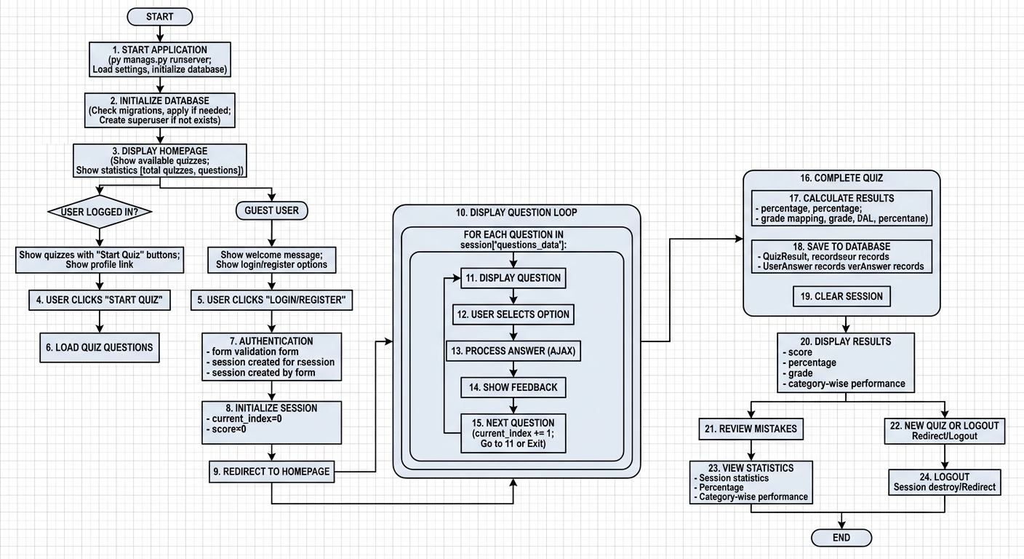

5.3 Data Flow Diagram DFD:

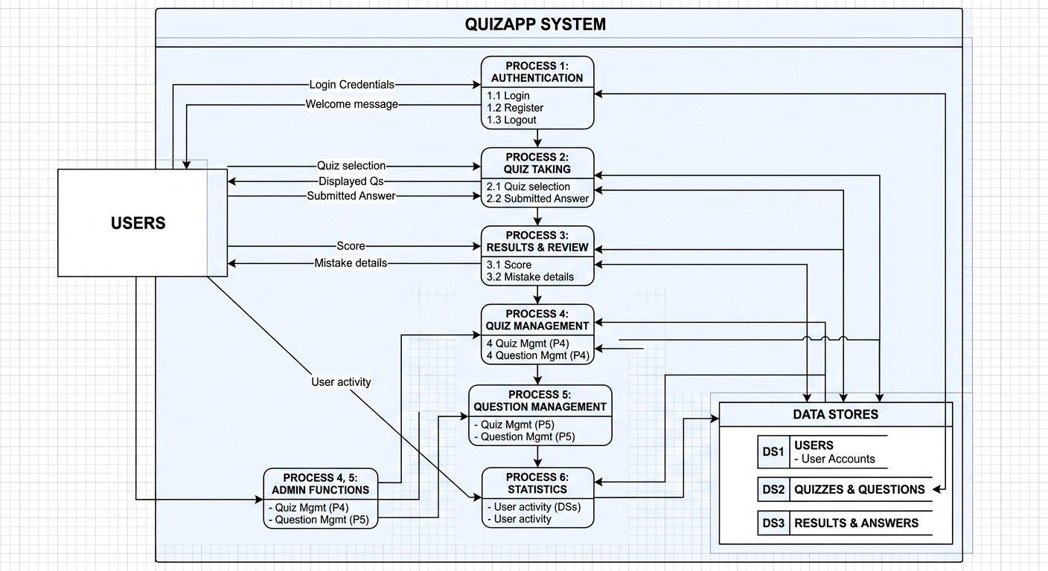

5.4 Class Diagram:

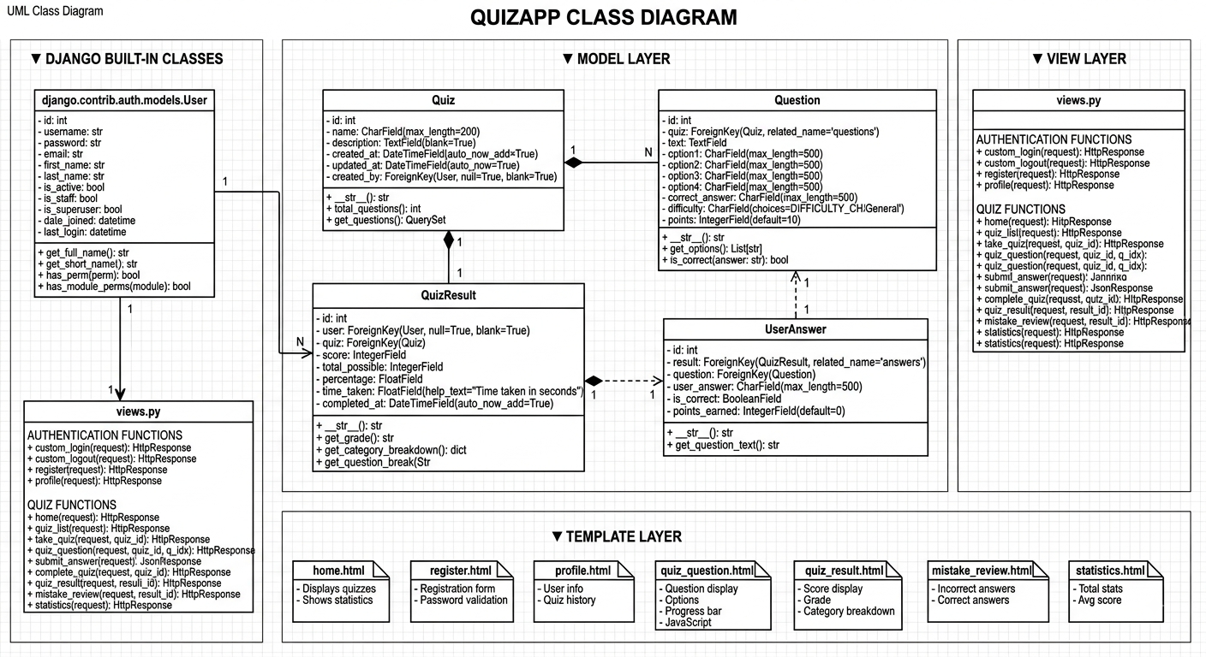

5.5 Use Case Diagram:
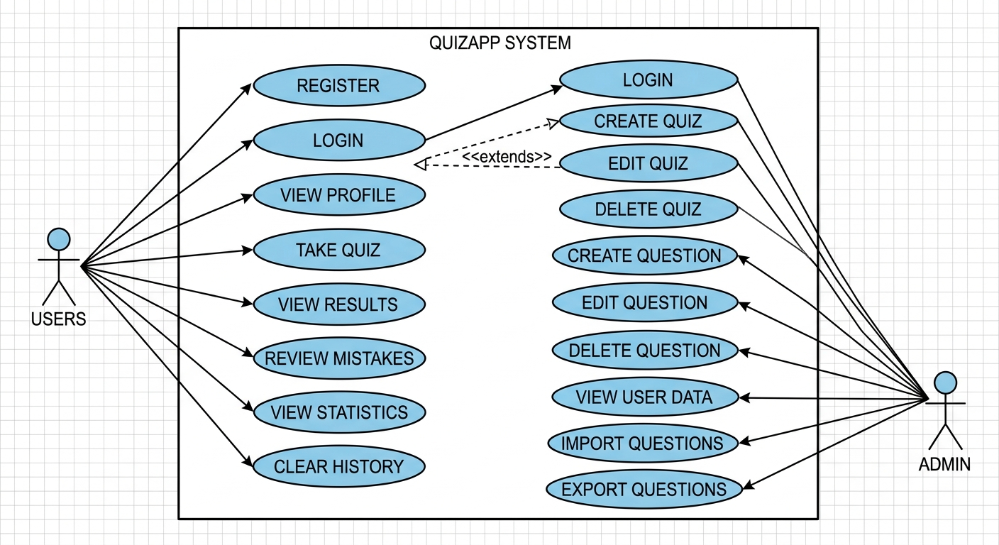

5.6 Sequential Diagram:

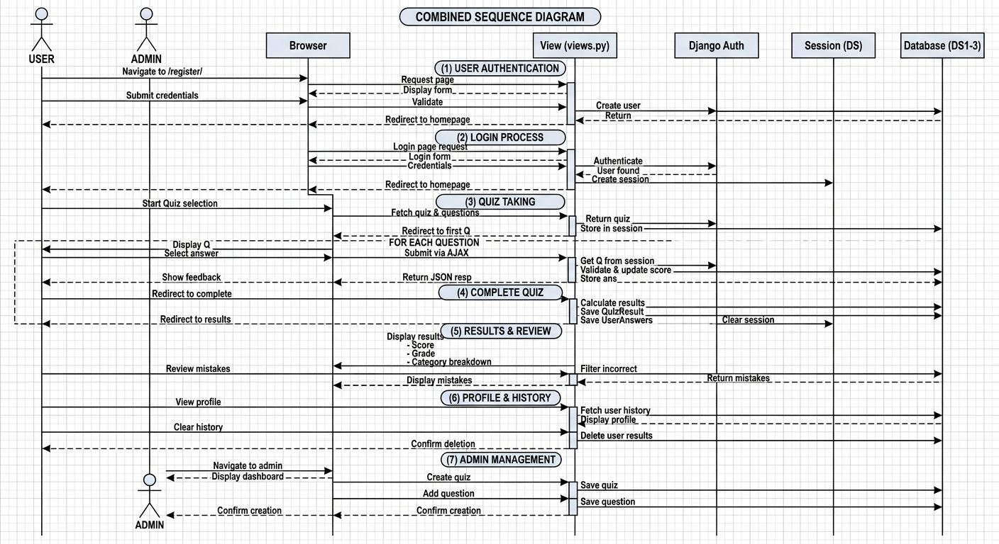

5.7 Activity Diagram
Student Exam Activity:
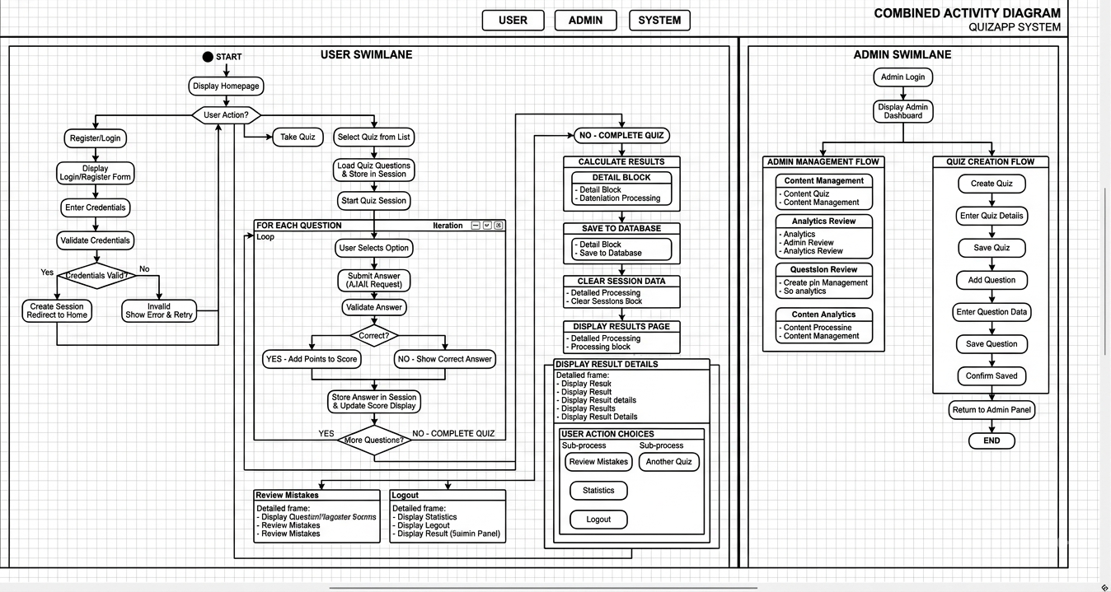

5.8 Database Design / File Structure

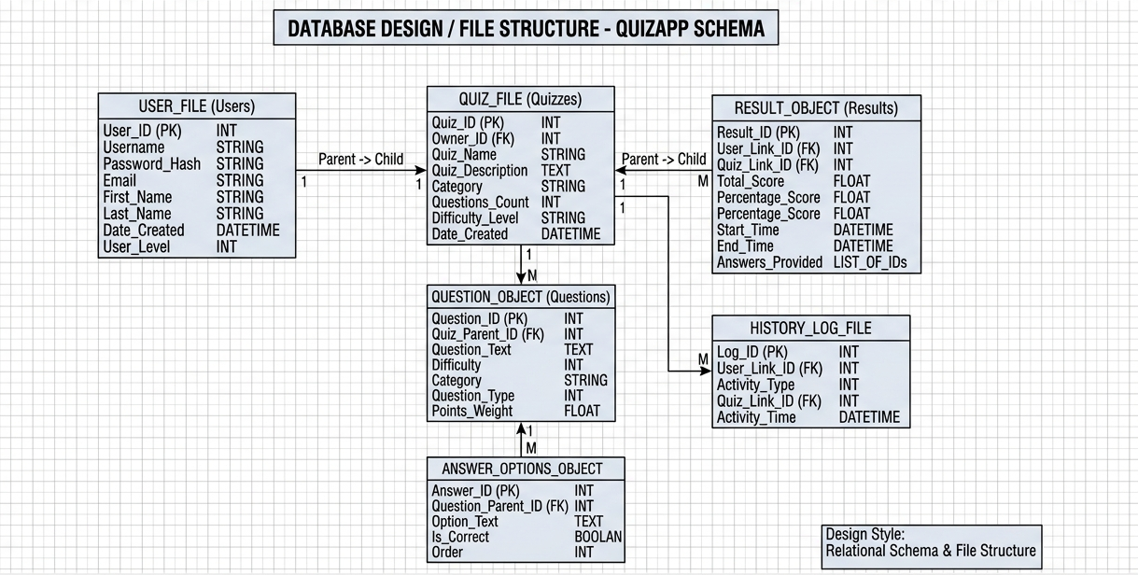

5.9 Menu Design

Main Menu:

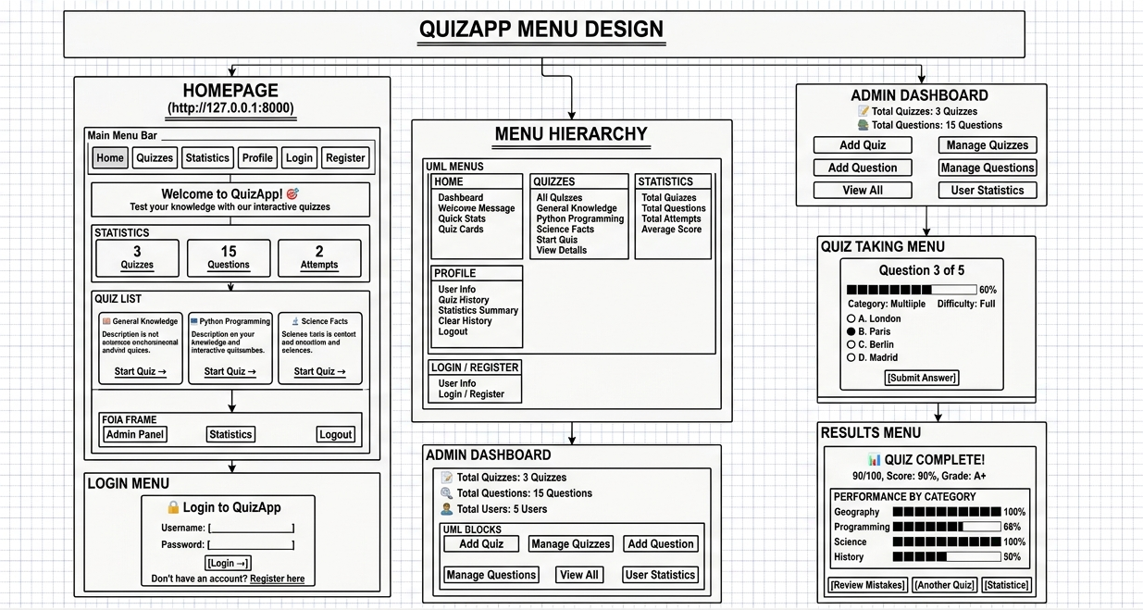

5.10 Screen Design

Student Login Screen:

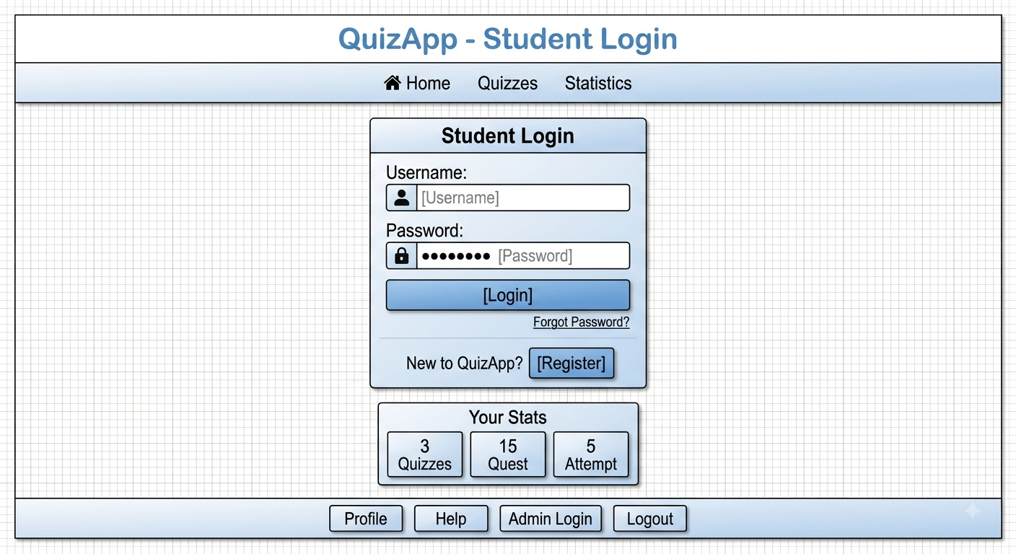

5.11 Code Structure
The Offline Quiz App follows a modular, package-based architecture. All source code is organized under the base package quizapp, with three sub-packages: models, ui, and utils. The entry point is QuizApp.java directly under quizapp.

File Organization:

Package: quizapp
QuizApp.java
Contains the main() method. Responsibilities:
  - Call DataInitializer.initialize() to create the questions.txt file if it does not exist.
  - Launch the login window (LoginFrame) using java.awt.EventQueue.invokeLater().

Package: quizapp.models
Contains the data model classes (plain Java objects with business logic).
- User.java
Represents a registered user.
Attributes: username, password, totalScore, quizzesTaken.
Methods: constructors, getters, addScore(int), toString(), fromString(String) for file serialization.
- Question.java
Represents a single quiz question.
Attributes: id, category, question, options (List<String>), correctOptionIndex, timeLimitSeconds
Methods: constructors, getters, isCorrect(int).
- Quiz.java
Manages the state of an ongoing quiz.
Attributes: category, questions (List<Question>), currentQuestionIndex, score, userAnswers (List<Integer>).
Methods: getCurrentQuestion(), hasNext(), submitAnswer(int), getResult().
- QuizResult.java
Holds the result of a completed quiz.
Attributes: username, category, score, totalQuestions, dateTime (LocalDateTime), userAnswers.
Methods: constructors, getters, getPercentage(), toString().

Package: quizapp.ui
Contains all Swing-based graphical user interface windows (each extends JFrame).
- LoginFrame.java
First window shown. Contains text fields for username/password, Login and Sign Up buttons.
Methods: initComponents(), login(), openSignUp().
- SignUpFrame.java
Window for new user registration. Contains username, password, confirm password fields, and Sign Up / Back buttons.
Methods: initComponents(), signUp().
- CategorySelectionFrame.java
Main menu after login. Shows a grid of category buttons (retrieved from questions.txt), plus “View History” and “Logout” buttons.
Methods: initComponents(), startQuiz(String), viewHistory(), logout().
- QuizFrame.java
The quiz-taking window. Displays one question at a time with four radio buttons, a timer label, and a “Submit Answer” button.
Methods: initComponents(), loadNextQuestion(), startTimer(int), submitAnswer(), finishQuiz().

Package: quizapp.utils
Contains helper classes for data persistence and initialisation.
- DataManager.java
Provides static methods for all file I/O operations.
Methods:
- User: saveUser(User), getAllUsers(), findUser(String, String)
- Question: loadQuestions(), getQuestionsByCategory(String), getCategories()
- Result: saveResult(QuizResult)
File constants: USERS_FILE, QUESTIONS_FILE, RESULTS_FILE.
- DataInitializer.java
Static methods to create default data files if they do not exist.
Methods: initialize(), createQuestionsFile() (writes 10 sample questions).

File Storage (External to Code)
Three plain text files are used as a lightweight database. They are created automatically in the project root directory:
- users.txt – CSV format: username,password,totalScore,quizzesTaken
- questions.txt – Pipe-separated with comma-separated options:
id|category|question|opt1,opt2,opt3,opt4|correctIndex|timeLimit
- results.txt – CSV format: username,category,score,totalQuestions,dateTime

Code Dependencies & Relationships
- QuizApp → creates LoginFrame
- LoginFrame → opens SignUpFrame or CategorySelectionFrame (on successful login)
- CategorySelectionFrame → creates QuizFrame when a category is selected
- QuizFrame → uses Quiz (from models) and DataManager (from utils)
- Quiz → uses Question and QuizResult
- DataManager → reads/writes User, Question, QuizResult from/to text files
- DataInitializer → called once at application startup to ensure questions.txt exists

Total Files
Package | Files
quizapp | 1 (QuizApp.java)
quizapp.models | 4 (User.java, Question.java, Quiz.java, QuizResult.java)
quizapp.ui | 4 (LoginFrame.java, SignUpFrame.java, CategorySelectionFrame.java, QuizFrame.java)
quizapp.utils | 2 (DataManager.java, DataInitializer.java)
Total | 11 Java source files
Chapter 6: Conclusion

6.1 Project Achievement:
The QuizApp project successfully achieved all the objectives set at the beginning. Below are the key accomplishments:
i. Fully Offline Functionality
- The application runs completely without an internet connection.
- All data (users, questions, results) is stored locally in SQLite database.
- No external database or web server is required.
ii. User Authentication System
- Implemented secure login, registration, and logout features.
- Passwords are hashed using Django's built-in PBKDF2 algorithm.
- sessions persist across application restarts (scores and history saved).
iii. Modular Code Architecture
- The project follows Django's MVT (Model-View-Template) architecture.
- Clear separation of concerns with models, views, templates, and utilities.
- Total of 18 files with well-defined responsibilities.
iv. Modern Graphical User Interface
- Developed a responsive web-based interface using HTML5, CSS3, and JavaScript.
- Implemented interactive features including progress bars, modals, and animations.
- Designed with gradient color scheme and professional card-based layout.
v. Category-Based Quiz System
- Questions are organized into categories (e.g., General Knowledge, Science, History, Technology, Geography).
- Users can select any available category.
- Categories are dynamically loaded from the database.
vi. Difficulty-Based Scoring
- Each question has configurable difficulty levels (Easy, Medium, Hard, Expert).
- Different point values per difficulty (10, 20, 30, 50 points respectively).
- Score calculation based on difficulty level.
vii. Automatic Scoring & Result Display
- The system calculates the score based on correct answers.
- After the last question, the user sees the final score, percentage, and grade (A+, A, B, C, F).
- Results are saved to the database with a timestamp.
- Category-wise performance breakdown displayed.
viii. Database Persistence
- Created five structured database tables using Django ORM.
- Implemented models for Quiz, Question, QuizResult, and UserAnswer.
- Migrations track database schema changes.
ix. User Profile and History
- Each user has a profile displaying total quizzes taken and average score.
- Complete quiz history is stored and displayed.
- Clear history feature with confirmation modal.
x. Mistake Review
- Users can review all incorrect answers after completing a quiz.
- Shows question, user's wrong answer, and correct answer.
- Facilitates learning from mistakes.
xi. Security Features
- CSRF protection for all forms.
- Session-based authentication.
- Login-required decorators for protected views.
- Admin-only access to management features.
xii. Learning Outcomes
- Gained practical experience in Django framework, SQLite database, HTML/CSS/JavaScript, and object-oriented design.
- Understood the importance of modularity, security, and documentation in software development.
All planned features (user authentication, category selection, difficulty-based scoring, results, mistake review, profile management, and statistics) are fully implemented and tested. The application runs reliably on any system with Python 3.7 or higher and Django 4.2+.

6.2 Key Features Implemented:
Below is a concise list of the main features that have been successfully implemented in QuizApp:

I. User Management
- User Registration – New users can create an account with username, password, and password confirmation.
- User Login – Existing users can log in with their credentials.
- User Logout – Users can log out with confirmation modal.
- Session Persistence – User data (quiz history, statistics) is saved across sessions.

II. Quiz Navigation
- Quiz Selection – Users can choose from multiple available quizzes.
- Dynamic Question Loading – Questions are loaded from the database based on the selected quiz.
- Sequential Question Flow – Questions are presented one at a time, in order.
- Progress Tracking – Visual progress bar shows completion percentage.

III. Quiz Mechanics
- Multiple Choice Questions – Each question has four possible answers.
- Difficulty-Based Scoring – Questions have difficulty levels (Easy, Medium, Hard, Expert) with varying point values (10, 20, 30, 50).
- Answer Recording – The user's selected option is recorded.
- Score Calculation – Score is incremented automatically for each correct answer.
- Instant Feedback – Users receive immediate feedback after each answer (Correct/Wrong).

IV. Result Handling
- Instant Result Display – After the last question, the user sees the final score, percentage, and grade (A+, A, B, C, F).
- Result Persistence – Each quiz result is saved to the database with username, quiz, score, and timestamp.
- Category Breakdown – Performance displayed by category (correct/total and percentage).
- User Statistics – Total quizzes taken and average score updated on profile.

V. Mistake Review
- Review Incorrect Answers – Users can review all mistakes after completing a quiz.
- Correct Answers Displayed – Shows correct answer alongside user's wrong answer.
- Learning Support – Facilitates learning from errors.

VI. Database Storage (SQLite)
- Quiz Table – Stores quiz name, description, and metadata.
- Question Table – Stores questions, options, correct answers, categories, difficulty levels, and points.
- QuizResult Table – Stores quiz history for all users.
- UserAnswer Table – Stores individual answers for each quiz attempt.
- Automatic Migrations – Database schema updates managed through Django migrations.

VII. Modern Graphical User Interface
- Homepage – Displays available quizzes and platform statistics.
- Login Screen – Login form with username/password fields and register link.
- Registration Screen – Registration form with validation.
- Profile Screen – User information, statistics, and quiz history with clear history option.
- Quiz Screen – Question display, radio button options, progress bar, and score display.
- Results Screen – Comprehensive results with grade and category breakdown.
- Mistake Review Screen – Detailed review of incorrect answers.
- Responsive Design – Works on desktop, tablet, and mobile devices.

VIII. Error Handling & Validation
- Empty Field Validation – Prevents empty username/password during registration.
- Password Matching – Ensures password and confirm password match.
- Duplicate Username Check – Prevents registration of an existing username.
- Invalid Login Handling – Displays an error message for incorrect credentials.
- CSRF Protection – All forms protected against cross-site request forgery.

IX. Modular Code Architecture
- Package Structure – Organized with clear separation: models, views, templates, and static files.
- Reusable Utilities – File handlers and session management centralized.
- Clear Separation of Concerns – UI, business logic, and data persistence are independent.

X. Security Features
- Password Hashing – Passwords stored securely using Django's PBKDF2 algorithm.
- Login-Required Decorators – Protected views accessible only to authenticated users.
- Admin Protection – Admin panel accessible only to staff users.
- Session Management – Secure session-based authentication.
These features collectively deliver a complete, offline quiz experience that is easy to use, maintain, and extend.

6.3 System Reliability:
The QuizApp is designed to be reliable and robust for everyday use. Its reliability stems from the following aspects:
i. Database Integrity – All user data, questions, and results are stored in a SQLite database with strict schema validation. The Django ORM validates read/write operations and gracefully handles missing tables by creating them automatically via migrations. This prevents crashes due to absent data structures.
ii. Error Handling – Critical operations (database queries, user input validation, session management) are wrapped in try-except blocks. Exceptions are logged without crashing the application. For example, if a database query fails, the system handles the error gracefully and notifies the user appropriately.
iii. Input Validation – All user inputs are validated before processing:
- Empty username/password are rejected at registration.
- Password confirmation must match.
- Duplicate usernames are detected and prevented.
- CSRF tokens validate all form submissions.
iv. Session Consistency – User scores and quiz results are updated only after successful completion of a quiz. Data is stored in session during quiz taking, and only saved to the database upon completion. If the application is closed unexpectedly during a quiz, no partial results are saved, preserving data integrity.
v. Database Transactions – Django's ORM provides transaction support, ensuring that related database operations (saving QuizResult and UserAnswer records) are atomic. If any operation fails, all changes are rolled back, maintaining database consistency.
vi. Platform Independence – The application runs on any system with Python 3.7 or higher and Django 4.2+. File paths use relative references, making the project portable across folders and drives.
vii. Secure Authentication – Passwords are hashed using Django's PBKDF2 algorithm with salt, preventing plain-text password storage. Session-based authentication ensures user data remains secure.
viii. Graceful Degradation – If the database contains malformed data, those records are skipped during queries, and the system continues to function. The application never hangs or crashes due to a single erroneous entry.
These measures ensure that QuizApp provides a stable and trustworthy environment for conducting quizzes.

Chapter 7: Learning During Project Work:

7.1 Technical Skills Acquired:
During the development of QuizApp, the following technical skills were gained or strengthened:
i. Python Programming Language
- Object-oriented concepts: classes, inheritance, encapsulation, polymorphism.
- Use of collections: lists, dictionaries, tuples for data manipulation.
- Exception handling with try-except blocks.
- File I/O using Python's built-in file handling methods.
ii. Django Framework (Web Development)
- Creating and configuring Django projects and applications.
- Understanding MVT (Model-View-Template) architecture.
- URL routing and view functions.
- Template rendering with Django Template Language.
- Form handling and validation.
- Session management for user state.
- Django ORM for database operations.
iii. Database Management
- Designing database models using Django ORM.
- Performing CRUD operations through ORM.
- Managing database migrations.
- Working with SQLite3 database.
iv. Frontend Development
- HTML5 for structuring web pages.
- CSS3 for styling and responsive design.
- JavaScript for client-side interactivity.
- AJAX for asynchronous form submissions.
- Working with the Document Object Model (DOM).
v. User Interface Design
- Creating responsive and user-friendly interfaces.
- Implementing gradient backgrounds and modern card layouts.
- Designing modal dialogs and confirmation prompts.
- Using progress bars and visual feedback mechanisms.
vi. Web Security
- Implementing CSRF protection.
- Using Django's authentication framework.
- Implementing login-required decorators.
- Securing admin access.
vii. Modular Software Design
- Organizing code into logical components (models, views, templates, static files).
- Separating concerns: data, business logic, presentation.
- Writing reusable functions and utilities.
viii. Debugging & Testing
- Using Django debug mode for error tracing.
- Testing edge cases and user input validation.
- Using browser developer tools for frontend debugging.
- Validating user input to prevent runtime errors.
ix. Version Control
- Using Git for source code management.
- Tracking changes and maintaining project history.
x. Documentation
- Writing self-documenting code with meaningful variable and function names.
- Preparing project reports with system architecture, algorithms, and screen designs.
- Documenting code structure and dependencies.
These skills are directly transferable to other web applications and provide a strong foundation for advanced development (e.g., Django REST Framework, Flask, React).

7.2 Project Management Skills:
Developing QuizApp from concept to completion involved several project management skills, which are valuable for any software development endeavour.
i. Project Planning
- Defined clear objectives, scope, and deliverables before writing any code.
- Broke down the project into smaller, manageable modules (authentication, quiz engine, database, UI).
- Created a timeline with milestones (e.g., complete user model, implement database, build views, integrate all components).
ii. Task Prioritisation
- Identified core features (login, quiz taking, scoring) as high priority.
- Deferred non-essential features (import/export, advanced analytics) to future enhancements.
- Focused on completing a working prototype first, then added refinements.
iii. Resource Management
- Used only free, open-source tools: Visual Studio Code, Python, Django, and SQLite.
- Leveraged online documentation (Django Docs, Stack Overflow, Python Docs) efficiently.
- Managed time effectively by allocating specific hours for coding, testing, and documentation.
iv. Risk Assessment & Mitigation
- Anticipated potential issues: database corruption, invalid user input, session management errors.
- Implemented error handling (try-except blocks) and validation to reduce risks.
- Created backup plans: using migrations to recover database schema, session fallback mechanisms.
v. Progress Tracking
- Maintained a simple checklist of completed tasks (e.g., "User model done", "Login view working").
- Regularly tested each module independently before integration.
- Used version control (Git) to track changes and revert if needed.
vi. Quality Assurance
- Performed unit testing on individual classes (e.g., User authentication, Quiz submission).
- Conducted integration testing to ensure views, models, and templates work together.
- Ran user acceptance tests by simulating real user scenarios (register, take quiz, logout).
vii. Documentation Management
- Prepared a comprehensive project report covering all required chapters (introduction, design, implementation, results).
- Maintained inline code comments for clarity.
- Organised diagrams (flowchart, DFD, class diagram) as separate deliverables.
viii. Communication (Self Project Context)
- Although a solo project, practiced clear self-documentation to explain design decisions.
- Simulated stakeholder communication by writing a user manual and technical guide.
These project management skills not only ensured the successful completion of QuizApp but also provide a transferable framework for future group or professional projects.
7.3 Future Enhancements:
QuizApp is designed with a modular architecture, making it easy to extend with new features. Below are potential enhancements that can be added in future versions.
i. Enhanced User Experience
- View History – Display a detailed list of past quiz attempts (quiz name, score, date) in a tabular format.
- Profile Page – Allow users to view their total quizzes taken, average score, and performance trends.
- Password Change – Let users change their password after login.
- Password Recovery – Add "Forgot Password" feature using security questions or email verification.
ii. Quiz Improvements
- Multiple Question Types – Support true/false, fill-in-the-blank, and matching questions.
- Randomised Questions – Shuffle the order of questions for each quiz attempt.
- Review Answers – Allow users to review their answers before final submission.
- Skip Question – Add a "Skip" button to move to the next question without answering (counts as wrong).
iii. Reporting & Analytics
- Export Results – Save quiz results as PDF or Excel files.
- Performance Charts – Display graphical progress over time using charts (e.g., line chart of scores).
- Category-wise Breakdown – Show strengths and weaknesses by category with visual indicators.
iv. Multimedia & Accessibility
- Images in Questions – Support images as part of the question or options.
- High Contrast Theme – Provide a theme option for better accessibility.
- Audio Feedback – Play sounds for correct/incorrect answers and quiz completion.
v. Security Enhancements
- Session Lock – Automatically log out after a period of inactivity.
- Question Encryption – Encrypt sensitive data to prevent tampering.
vi. Database Enhancements
- PostgreSQL/MySQL Support – Allow switching to more robust databases for production use.
- Concurrent Access – Support multiple users accessing the system simultaneously.
vii. Gamification
- Achievements/Badges – Award badges for milestones (e.g., first quiz, 100% score, 10 quizzes taken).
- Leaderboard – Display top scores among all users.
- Daily Challenges – Offer a special quiz each day.
viii. Web Deployment
- Cloud Hosting – Deploy the application on platforms like PythonAnywhere, Render, or Heroku.
- Mobile Responsive – Further enhance mobile responsiveness for tablet and phone access.

Chapter 8: Bibliography:

8.1 Online References:
The following online resources were consulted during the development of QuizApp:
i. DeepSeek (AI Assistant) – Provided end-to-end project guidance, including code generation (Django views, models, templates), documentation writing (chapters, diagrams, tables), debugging assistance, and report formatting.
- Available at: https://chat.deepseek.com/
ii. Django Official Documentation – Comprehensive guide to Django framework, covering models, views, templates, forms, authentication, and deployment.
- Available at: https://docs.djangoproject.com/
iii. Django Tutorial (Official) – Step-by-step tutorial covering the basics of Django, including project setup, database models, and view creation.
- Available at: https://docs.djangoproject.com/en/stable/intro/tutorial01/
iv. Django Model Documentation – Official reference for defining database models using Django ORM.
- Available at: https://docs.djangoproject.com/en/stable/topics/db/models/
v. Django Template Documentation – Guide to Django's template language for rendering HTML with dynamic content.
- Available at: https://docs.djangoproject.com/en/stable/topics/templates/
vi. Django Forms Documentation – Official documentation for creating and validating forms in Django.
- Available at: https://docs.djangoproject.com/en/stable/topics/forms/
vii. Django Authentication Documentation – Comprehensive guide to Django's authentication system (login, logout, registration, password management).
- Available at: https://docs.djangoproject.com/en/stable/topics/auth/
viii. Django URL Dispatcher – Documentation on URL routing and pattern matching in Django.
- Available at: https://docs.djangoproject.com/en/stable/topics/http/urls/
ix. Django Session Documentation – Guide to handling user sessions in Django.
- Available at: https://docs.djangoproject.com/en/stable/topics/http/sessions/
x. Stack Overflow – Community-driven Q&A platform for practical solutions to specific programming challenges in Django, Python, and web development.
- Available at: https://stackoverflow.com/
xi. MDN Web Docs (HTML/CSS/JavaScript) – Comprehensive reference for frontend technologies used in templates.
- Available at: https://developer.mozilla.org/
xii. W3Schools – HTML/CSS/JavaScript Tutorials – Beginner-friendly resources for HTML, CSS, and JavaScript.
- Available at: https://www.w3schools.com/
xiii. Python Official Documentation – Complete reference for Python programming language.
- Available at: https://docs.python.org/3/

8.2 Offline References:
The following offline resources were consulted during the development of QuizApp:
i. "Django for Beginners" by William S. Vincent
- A comprehensive introduction to Django covering project setup, models, views, templates, forms, and authentication. Relevant for understanding the MVT architecture and building web applications with Django.
ii. "Two Scoops of Django: Best Practices for Django" by Daniel Roy Greenfeld & Audrey Roy Greenfeld
- A practical guide to Django best practices, covering project structure, code organization, and development methodologies. Used for understanding modular code architecture and project management in Django.
iii. "Python Crash Course" by Eric Matthes
- Covers Python fundamentals, object-oriented programming, and web development with Django. Relevant for understanding class design, file I/O, and Django integration.
iv. "Head First Python" by Paul Barry
- A visual, engaging introduction to Python, covering core concepts and web development. Relevant for understanding Python basics and Django framework.
v. "Effective Python: 90 Specific Ways to Write Better Python" by Brett Slatkin
- Provides best practices for writing clean, efficient, and maintainable Python code. Used for verifying syntax, code optimization, and exploring advanced topics.
vi. "Web Development with Django" by Andrew Pinkham
- A project-based guide to building web applications with Django, covering models, views, templates, and deployment. Relevant for understanding web application development with Django.
vii. Course Notes from Web Development (Django) - [Marwadi University]
- Lecture notes and lab exercises covering Django fundamentals, MVT architecture, database integration, and project development methodology.
viii. "HTML & CSS: Design and Build Websites" by Jon Duckett
- A beginner-friendly guide to HTML and CSS for building responsive, visually appealing web interfaces. Relevant for template design and UI development.
ix. "JavaScript and JQuery: Interactive Front-End Web Development" by Jon Duckett
- Covers JavaScript fundamentals, DOM manipulation, and AJAX for building interactive web applications. Used for client-side functionality in quiz templates.

Project Developed By:
- James Snortti Satiah
- Patrick Nyan Suah
- Paias Poiye
Rajkot, Academic Year: 2026-2027
Institution: Marwadi University Gujarat State India.

